

**NAME:**Momna Khurram Qureshi

**Sap_id:**55430

**Lab11:**Computer Architecture

**Submitted to:**Ma’am Ayesha

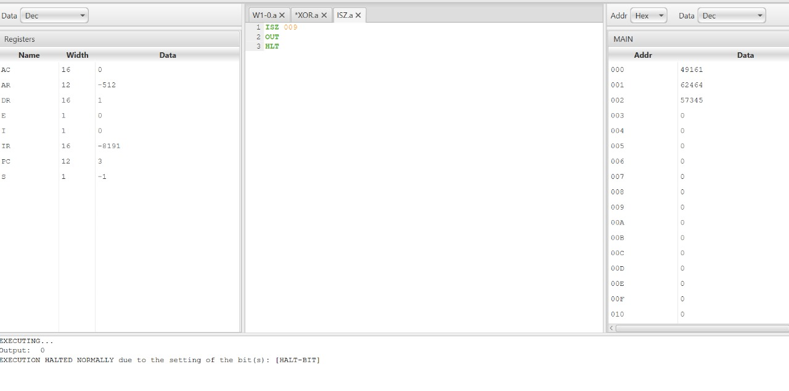 **CLASS WORK**

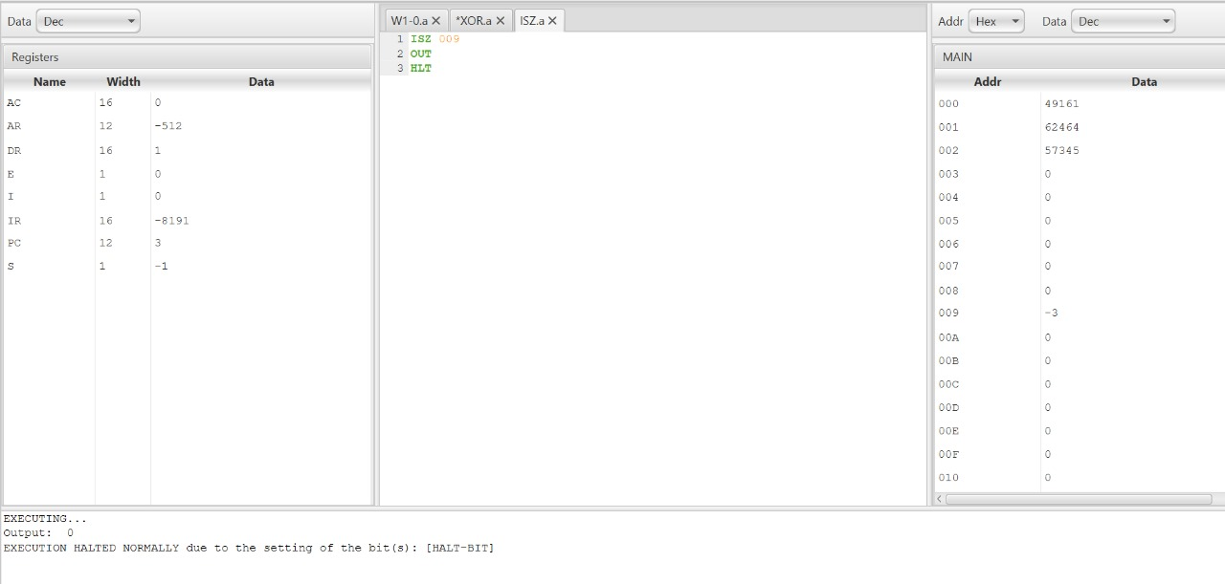**TASK 1**